**React JS**

Set of small project about React JS

1. **Page “Burger Builder”,** it contains: two pieces of bread, the user can choose the ingredients of the burger (Salad, Meat, Bacon, and Chees), and enables the user shown a list of the order containing the number and price of each component, using React.js.

**Home Burger**

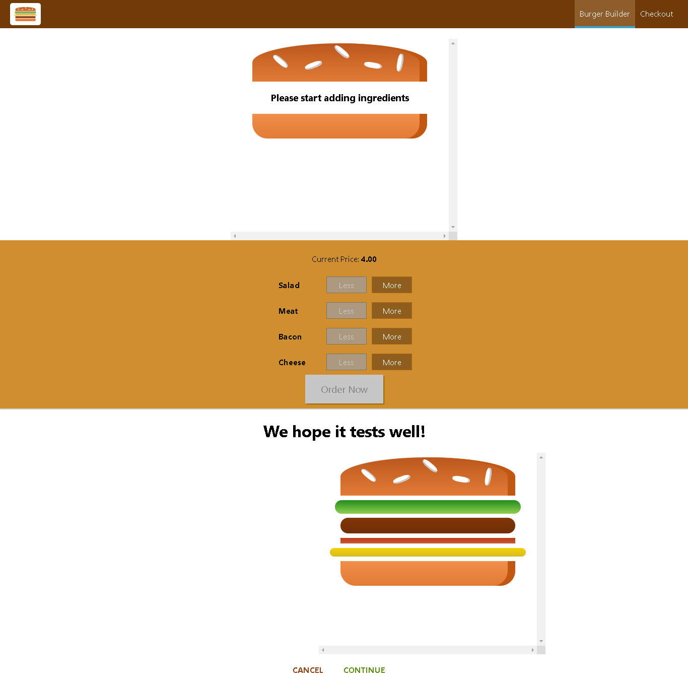

**Select Ingredient**

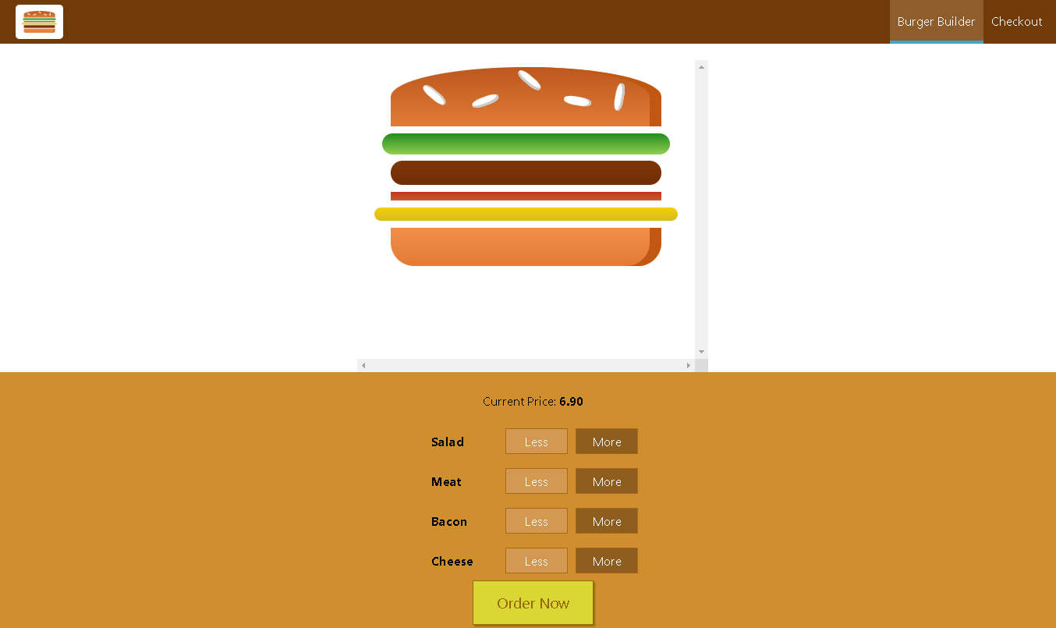

**Order List**

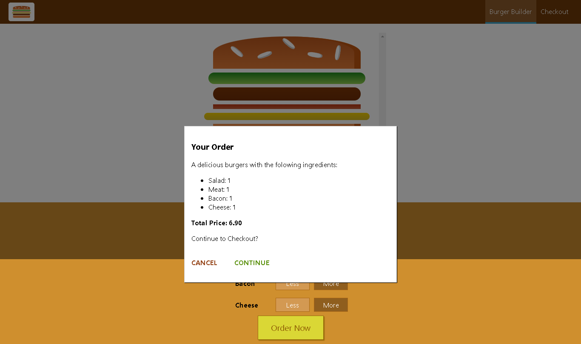

1. **Calculator,** you probably already know how these work. Add, subtract, multiply, divide… Clicking the numbers or the operations should perform the action.

For added challenge, respond to keyboard input too. You shouldn’t need to add an <input> element to make this work. If you do use an <input>, make it so that the user doesn’t need to focus the input control to type into it.

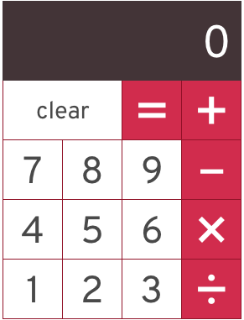

1. **Checklist**

A simple **React JS** To-do checklist that allows you to add tasks and mark them as complete.

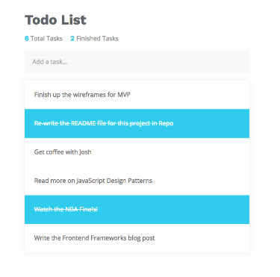

The Design of the App

ReactJS is the View V of the MVC that allows you to create simple and interactive User Interfaces. Since React is component-based, I used multiple components in order to pass the data down (top-down data flow) from the parent App to its children, perhaps the ListItem.